Airflow
- Apache airflow open-source tool used to schedule, automate, and monitor data engineering workflows
- In simple, run many data processing task automatically.
- Why need airflow
Imagine you are building a Data Engineering project.
We have these tasks:
- Extract data from a CSV file.
- Clean the data using Python.
- Store cleaned data in a database.
- Process data using PySpark.
- Generate reports.
Without Airflow, you may need to run each program manually.
With Airflow, you can automate the entire workflow.
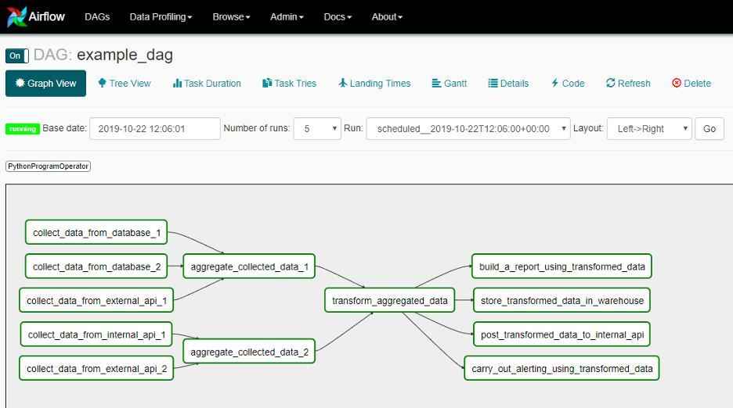

Advantages of airflow:
1.workflow automation – automatically executes data processing task
2.Task scheduling – run workflow at specific time
3.Task dependencies – execute task in correct order
4.Monitoring
5.Error handling
6.open source
7.Scalability – managae simple and complex data pipelines
8.Integrate – with python, sql, spark,databricks..

What is DAG in Apache Airflow?
- DAG stands for Directed Acyclic Graph.
- In Apache Airflow, a DAG defines a workflow by specifying:
  - What tasks need to be executed.
  - In what order tasks should execute.
  - What dependencies exist between tasks.
Example of DAG
Imagine a data engineering workflow:
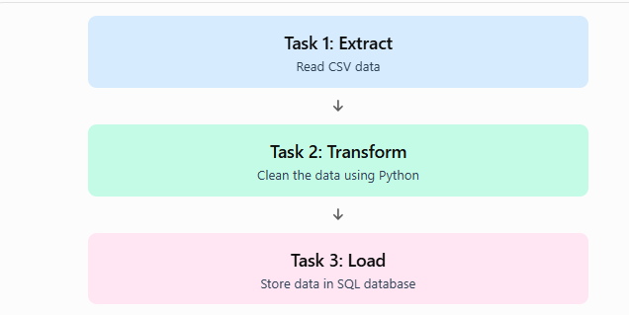

Here:
- Each box represents a Task.
- Arrows represent Dependencies.
- The complete workflow represents a DAG.
Task:
A Task is an individual unit of work or operation inside a DAG.
Examples:
- Extract data from a CSV file.
- Clean data using Python.
- Insert data into a SQL database.
- Send an email notification.
Each operation is considered a separate task.
Operator:
An Operator is a template or predefined component that defines what action a task should perform.
In simple words:
- Operator = Defines the type of work.
- Task = An instance of that work inside a DAG
Difference between Task and Operator
Task | Operator
Individual unit of work. | Defines how the work is performed.
Created inside a DAG. | Used to create tasks.
Represents an operation. | Provides the execution logic.
Example: Extract data. | Example: PythonOperator.

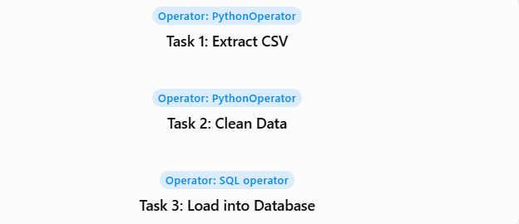

Installing airflow using docker:

docker run -d \
-p 8080:8080 \
--name airflow \
apache/airflow standalone

#show
docker ps
docker logs airflow

'admin': c5Pk6apQyuasHXW8

Side 3 line – traffic/port – then sign

docker exec -it airflow bash

list of task – workflow
repeat work – dag

cd /opt/airflow/dags --- change current directory

code

cat > retail_sales_dag.py <<'EOF'
from airflow import DAG
from airflow.providers.standard.operators.python import PythonOperator
from datetime import datetime
import csv

def create_sales():
with open("/tmp/retail_sales.csv", "w") as f:
writer = csv.writer(f)
writer.writerow(["product", "quantity", "price"])
writer.writerow(["Rice", 10, 1200])
writer.writerow(["Oil", 5, 1500])
writer.writerow(["Sugar", 8, 800])

def calculate_revenue():
total = 0

with open("/tmp/retail_sales.csv", "r") as f:
reader = csv.DictReader(f)

for row in reader:
total += int(row["quantity"]) * int(row["price"])

with open("/tmp/revenue_report.txt", "w") as f:
f.write(f"Total Revenue: {total}")

print("Total Revenue:", total)

def show_report():
with open("/tmp/revenue_report.txt", "r") as f:
print(f.read())

with DAG(
dag_id="retail_sales_pipeline",
start_date=datetime(2025, 1, 1),
schedule=None,
catchup=False
) as dag:

task1 = PythonOperator(
task_id="create_sales",
python_callable=create_sales
)

task2 = PythonOperator(
task_id="calculate_revenue",
python_callable=calculate_revenue
)

task3 = PythonOperator(
task_id="show_report",
python_callable=show_report
)

task1 >> task2 >> task3
EOF

To check the dags execution
airflow dags list

ui – go to dags – trigger it

admin': mKEZvaMGPeu99BWd

